Project Report

Hierarchical K-Means: Construction of Hashing Tree

Name: Revanth Kalluri
Course: AI & ML (Batch-5)
Problem Statement: Implement Hierarchical K-Means to perform customer segmentation.

Prerequisites:
Software used and how I installed them:
Python 3.6: Download and install anaconda using https://www.anaconda.com/download/. After installing anaconda, install below modules(packages), using anaconda prompt to run the commands.
Module | Command
numpy | pip install numpy
sklearn | pip install scikit-learn
pandas | pip install pandas

Pip is a package manager for python packages. Run “pip --version” in anaconda prompt to verify if pip is already installed. Run “conda install pip” to install pip for the first time.

Dataset used:
The dataset is a wholesale customer data obtained from the link - https://archive.ics.uci.edu/ml/machine-learning-databases/00292/Wholesale%20customers%20data.csv

Method used:
Hierarchical K-Means.

1. Importing necessary modules:
2. Read wholesale customer data:
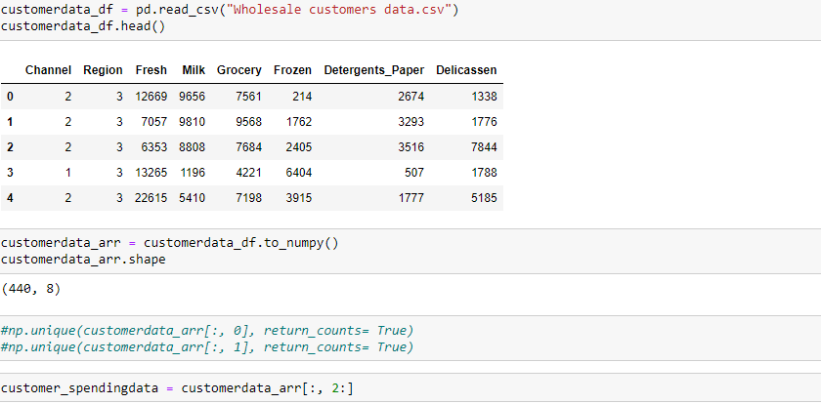
3. Define a function to split data at each node:
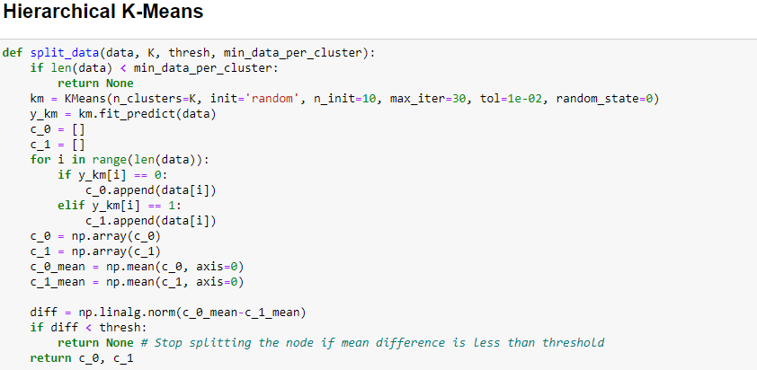

4. Function for Hierarchical KMeans:
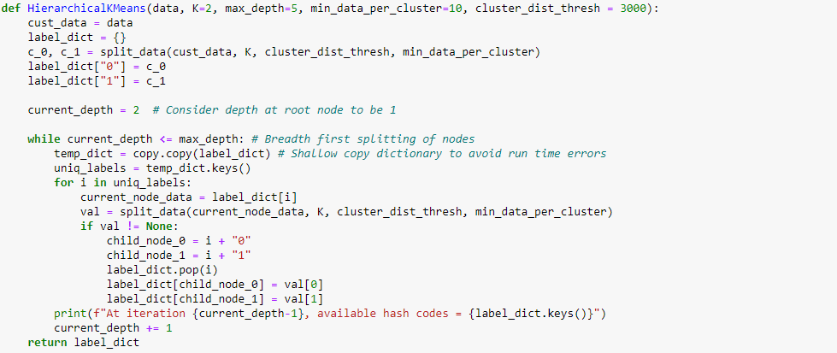
5. Segment customer data by implementing Hierarchical KMeans:
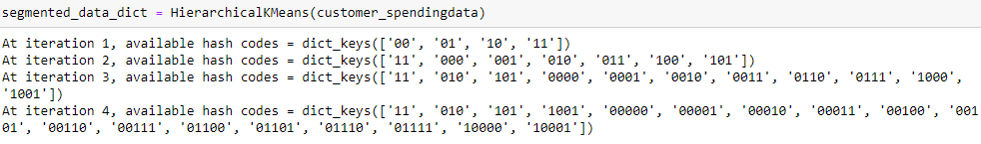
6. Display the hashcodes for segmented data in a Dataframe:
